**DAILY ONLINE ACTIVITIES SUMMARY**

|  |  |  |  |  |  |  |  |  |
| --- | --- | --- | --- | --- | --- | --- | --- | --- |
| **Date:** | **21/05/2020** | | | | | **Name:** | **Nivedita** | |
| **Sem & Sec** | **4th sem/A-sec** | | | | | **USN:** | **4al18cso53** | |
| **Online Test Summary** | | | | | | | | |
| **Subject** | | **MES** | | | | | | |
| **Max. Marks** | | **30** | | **Score** | | | **20** | |
| **Certification Course Summary** | | | | | | | | |
| **Course** | **Cloud virtualization concepts** | | | | | | | |
| **Certificate Provider** | | | **VMware** | | **Duration** | | | **9 hours** |
| **Coding Challenges** | | | | | | | | |
| **Problem Statement:1** **Write a C program to implement SRTF process scheduling.**  **Problem statement:2Write C Program to create Singly Liked List with n elements and reverse the elements using C.**  **Inbox**  **x** | | | | | | | | |
| **Status: competed** | | | | | | | | |
| **Uploaded the report in Github** | | | | | **yes** | | | |
| **If yes Repository name** | | | | | [**https://github.com/nivi-nivedita/lockdown-coding-program**](https://github.com/nivi-nivedita/lockdown-coding-program) | | | |
| **Uploaded the report in slack** | | | | | **yes** | | | |

Online Test Details: online test of MES was held on 10am to 10:30.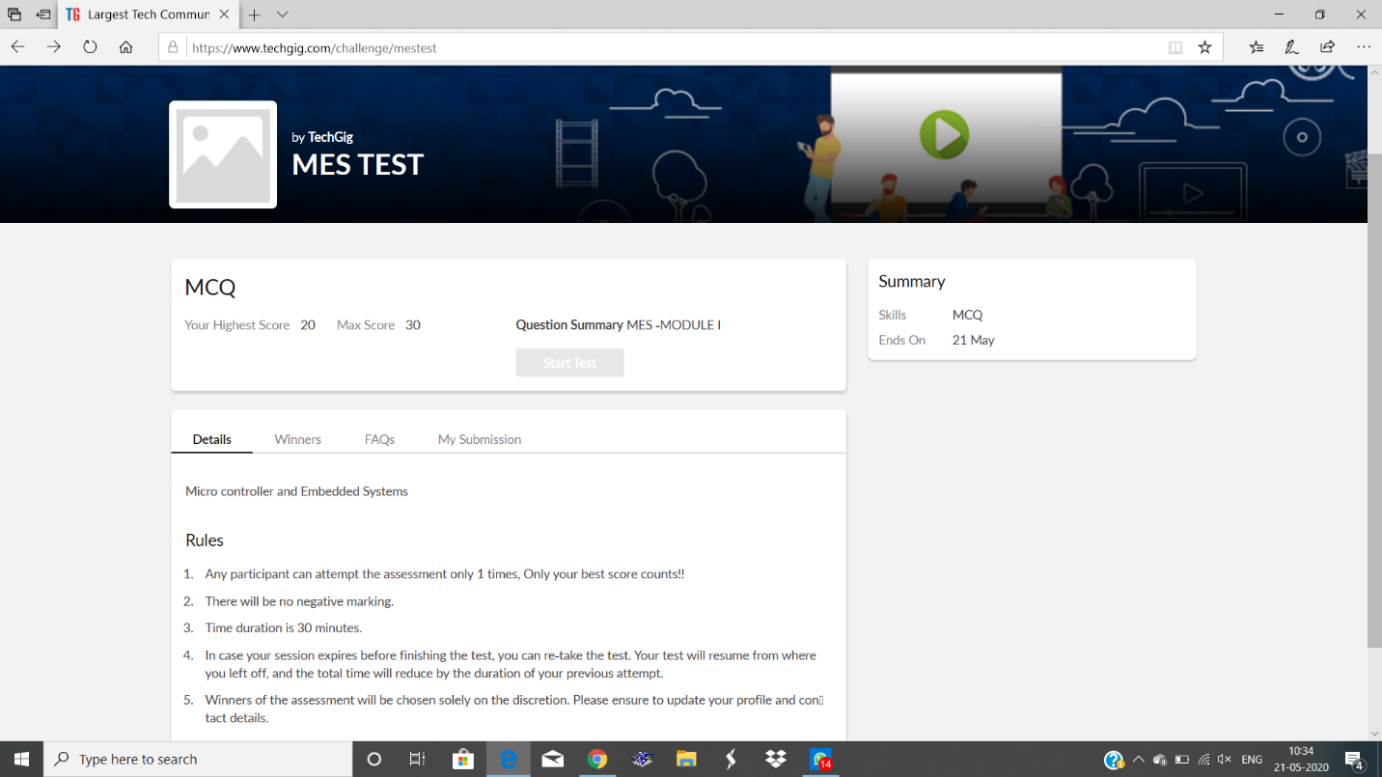

Certification Course Details: VM ware was conducting 3 course in that cloud virtualization concepts taken by me, I already completed 3 modules .its for 9 hours duration.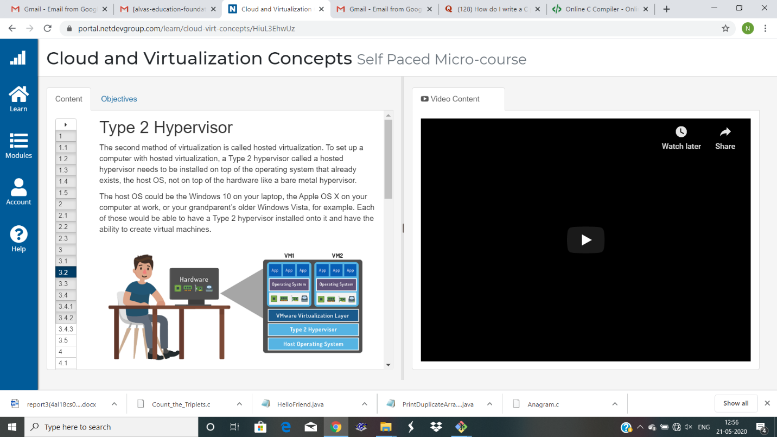

Coding Challenges Details: Write a C program to implement SRTF process scheduling.

Input: A set of processes with their burst time and arrival time

Output: The processes scheduled based on the arrival time and a smaller burst time.

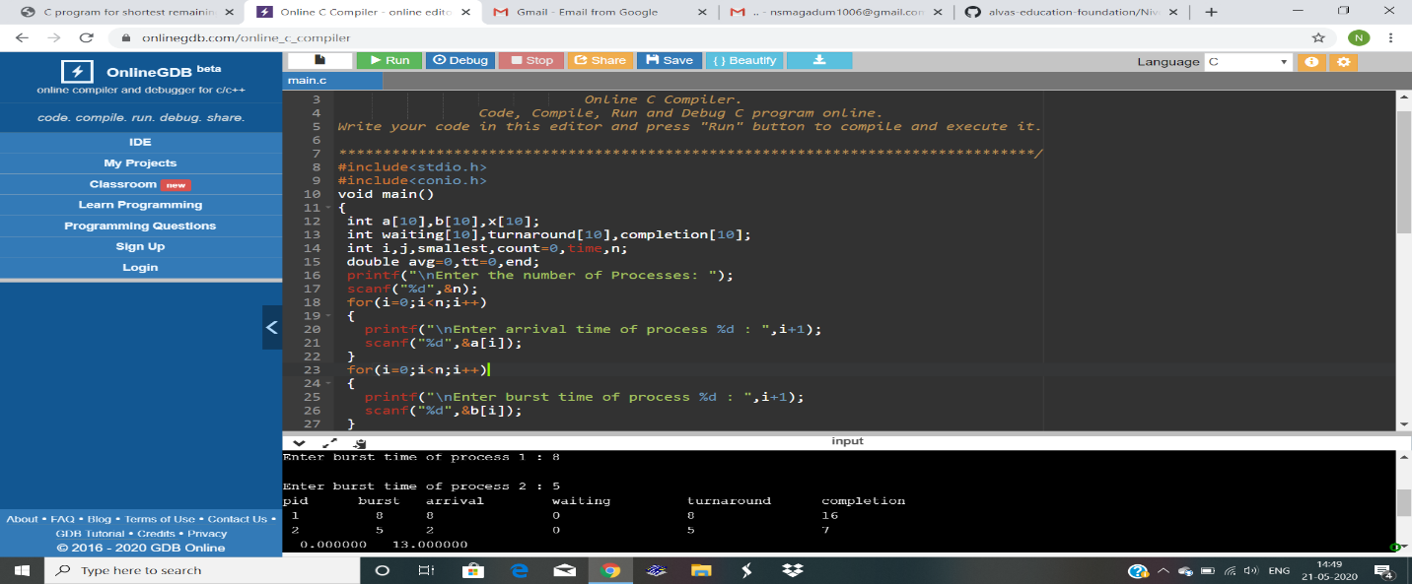program executed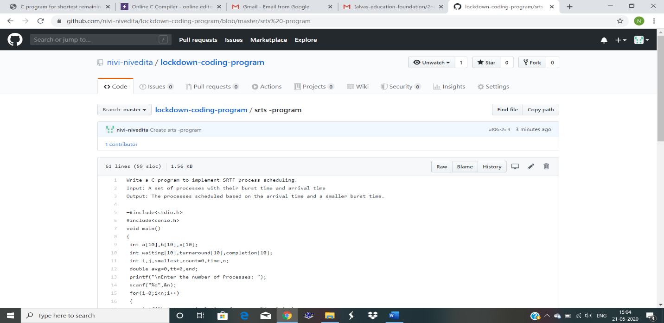.

2.program

Write C Program to create Singly Liked List with n elements and reverse the elements using C. 